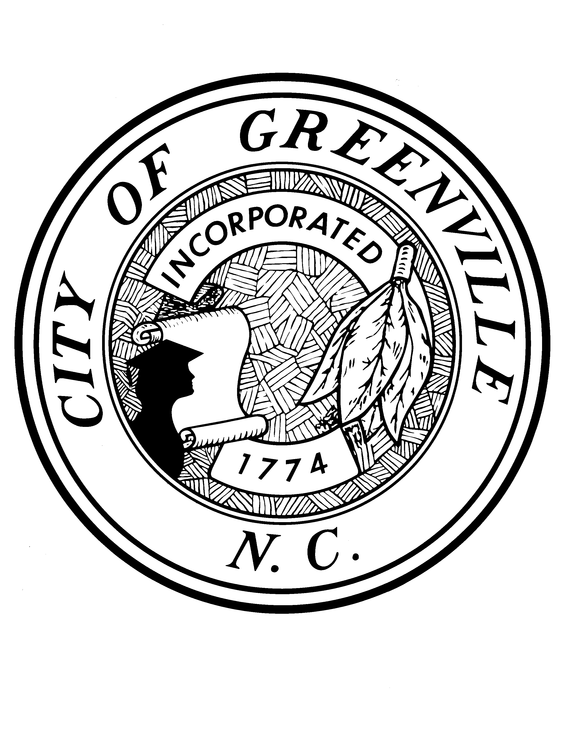
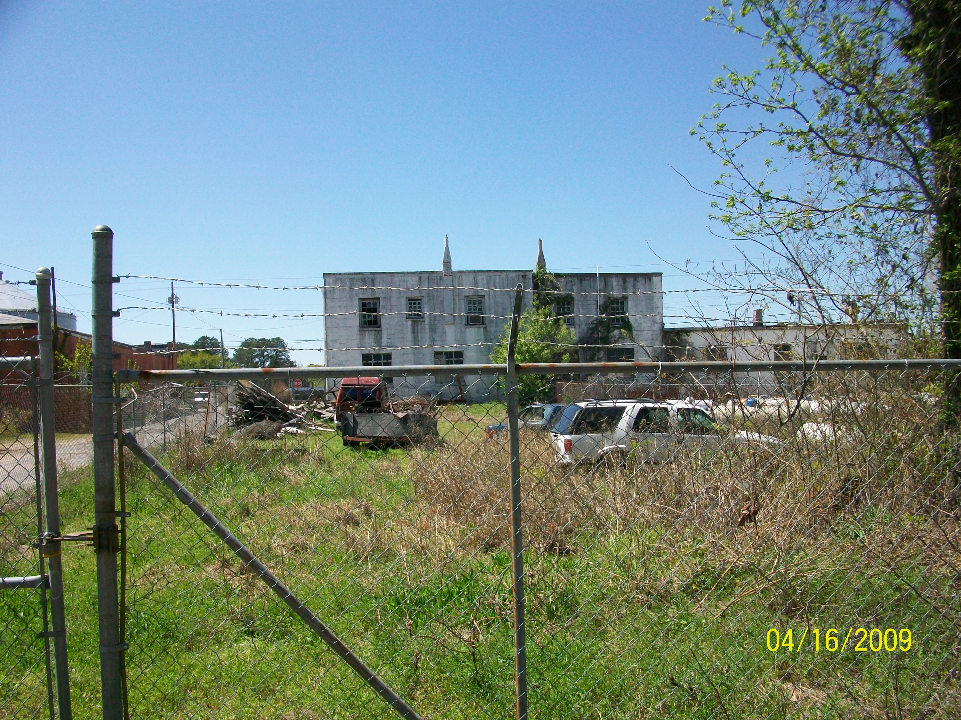

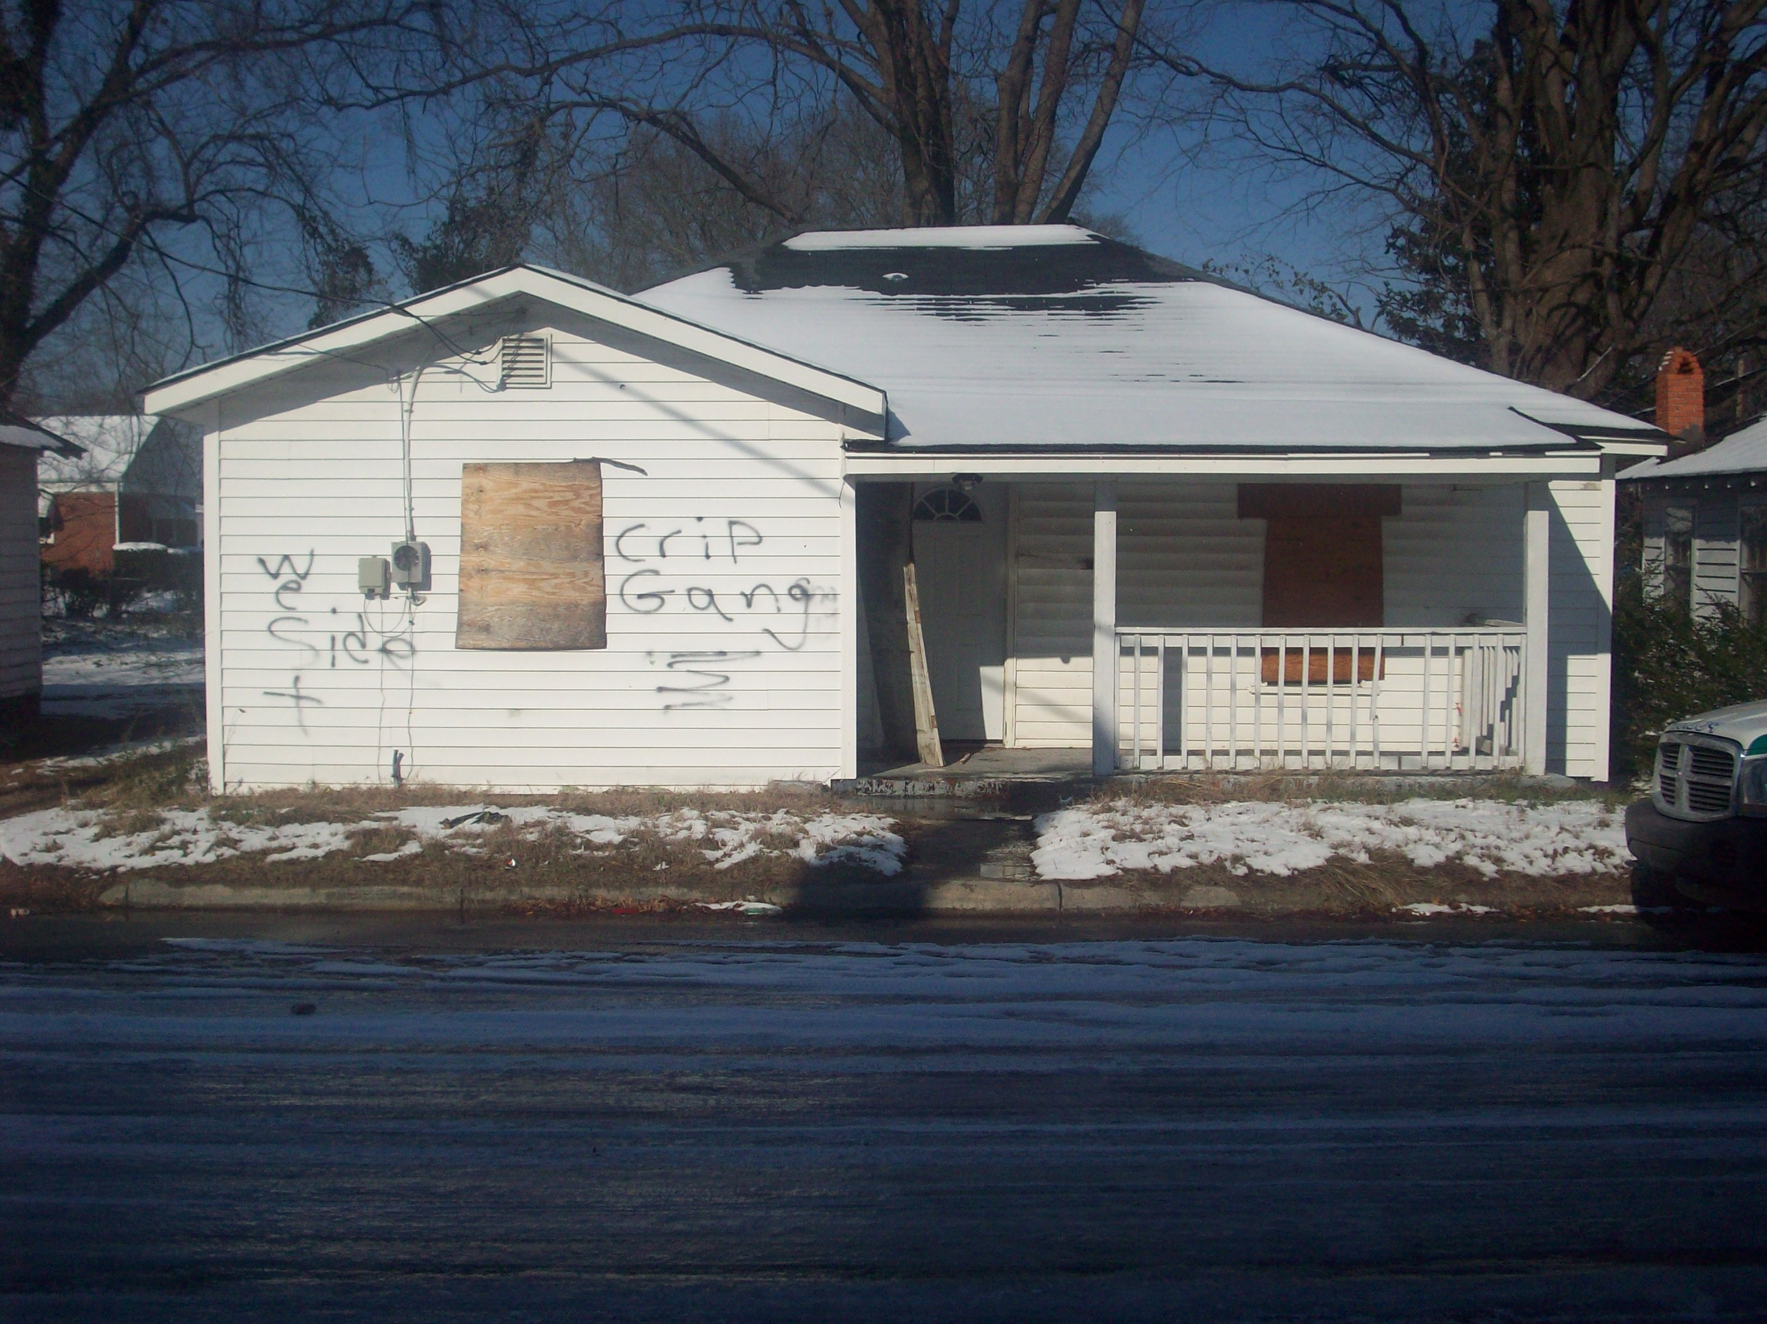

The Purpose
This pamphlet is for all residents and city staff to use to help reduce blight and to improve all properties in the City of Greenville. We welcome all residents and property owners to work alongside the Code Enforcement Division staff as partners in order to improve their neighborhoods.

The pamphlet is also designed as an active tool and is periodically updated so that residents and staff can better use resources in order to gain effective compliance.

Finally, this pamphlet seeks voluntary compliance by giving residents a user friendly approach to help them identify, understand and resolve violations in a timely and efficient manner.

Let’s all team up and work together in partnership to keep our community safe and clean!
Contact Information
Post Office Box 7207
Greenville, NC 27835 – 7207

City Municipal Building
201 West 5th Street, Second Floor
Greenville, NC 27834

Phone: 252-329-4110
Fax: 329-4231

www.greenvillenc.gov

Code Enforcement Division
Property Maintenance Standards

City of Greenville Police Department

Code Enforcement Division’s
Guide to Understanding

Property Maintenance Standards

Public Nuisance
Article A
Declared Nuisance Conditions [Sec. 12-3-3]
The following conditions represent a hazard to the health and safety of City inhabitants. As a resident or property owner, please remember to diligently identify and remove conditions immediately when they occur on your property. The failure to abate such conditions is unlawful by established city code and NC General Statute. Some conditions to look out for are:
- Breeding grounds for mosquitoes or rats or pests
- Vegetation/weeds over 10 inches
- Vegetation used by rodents as a breeding ground
- Growth of poison or noxious plants
- An open collection of stagnant water
- Combustibles e.g., paper, garbage, boxes, tires, trash, refuse, rags, brush, mattresses, and clothing
- Building material accumulation not suitable for construction or repairs
- Open garbage, food waste, animal waste
- Indoor household furniture or appliances and metal products when placed outside exposed to the weather elements
- Any jagged edges, e.g. metal, glass [auto parts]
- Open accumulation of trash, refuse, cans, bottles, or medical supplies
- Objects obstructing the view of motorist
- Any building or structure declared to be unsafe by the Chief Building Inspector
- Any improper drainage as determined by the Director of Public Works
- Any improper blockage of the natural flow of streams, creeks, surface waters
- Storm water retention device improperly used as determined by the Director of Public Works
- Any condition declared to be dangerous to public health, safety and a public nuisance as determined by the City Council
- Trash and debris left after a tenant is evicted and the property owner/mgr. fails to clean it up after 24 hours.

The City of Greenville Property Maintenance Standards

Chapter 4. Abandoned, Nuisance and Junk Vehicles

Section 12-4-1 Abandoned Motor Vehicle
- Left on the street in violation of an Ordinance
- Left on City owned property for over 24 hours
- Left on private property without the owner’s consent for two (2) hours or more
- Left on the street in the City over seven (7) days

Abandonment prohibited; Removal authorized. [Sec. 12-4-3]
…Nuisance Vehicle… declared to be a health or safety hazard:
- A breeding ground for rats, mosquitoes, or other pests
- A point of weed growth accumulation over 8 inches
- A point of pools of water
- A point of quantities of gasoline, flammable or explosive materials evidenced by odor
- One which cannot be operated from the inside with areas of confinement, e.g. a hood or a trunk
- Vehicle is in danger of falling
- A point of collection for garbage, food waste
- Vehicle has sharp or jagged edges, metal or glass
- Any vehicle declared to be a health and safety hazard by Neighborhood Services

Nuisance vehicles prohibited; Removal authorized. [Sec.12-4-4]
… Junk Motor Vehicle …if abandoned and
- It is partially dismantled or wrecked
- It cannot be self-propelled or moved
- It is more than five years old; worth less than $500.00
- It does not display a current license plate

Junked vehicles prohibited; Removal authorized. [Sec. 12-4-5]
Exception only if not a Nuisance Vehicle:
- One junk vehicle is allowed provided it is located in the rear yard with a cover concealing it from public view.
- Neighborhood Services staff determines whether the cover adequately conceals the vehicle.
- Any other junk vehicle must be stored in a garage or other building structure with a complete enclosure. The garage or enclosure must be lawfully built approved by the Building and Zoning Divisions.

Parking on Unimproved Surfaces [Sec. 9-4-248]

The City of Greenville prohibits parking on lawns or "unimproved surfaces". All parking areas shall be constructed with a hard surface, all weather material such as asphalt, concrete, brick, CABC or any other approved materials. Grass and bare earth are not acceptable. The parking area(s) shall be maintained in a safe, sanitary and neat condition. All spaces shall be marked clearly to be recognizable to the general public. The parking area cannot contribute to or increase soil erosion. The revised ordinance also states that it is the registered owner of the vehicle that will receive the citation, not the property owner on which the car is parked.

If a vehicle is in violation, they will be given a citation in the amount of twenty-five dollars ($25.00). Each time that a vehicle is in violation, a twenty-five dollar ($25.00) fine will be incurred. A vehicle cannot be given a citation unless it is actually seen on the property. Code Enforcement Officers inspect for parking on unimproved surfaces Monday through Friday, 8:00am until 5:00pm. Special events within the City of Greenville may warrant Officers providing additional inspections. This must be approved by the Code Enforcement Division Commander.

CURBSIDE STORAGE TIME LIMITS

Article A. General Provisions

Section 6-3-1 Definitions
- Garbage. The word “garbage” shall mean organic waste matter…(mostly) food waste…
- Refuse. The word “Refuse”…means ashes, tin cans, dirty rags, trash, house sweepings, paper, paper cups, shavings, bottles and other rubbish.
- Recyclables. The word “Recyclables” shall mean glass jars and bottles, aluminum, beverage cans, steel cans, cardboard, plastic [goods], newsprint, magazines, and other recyclable goods.
Section 6-3-4 Garbage Receptacles [24 hour removal of garbage receptacles]
(e) No person shall place [or store] receptacles for residential garbage… any earlier than dusk on the evening prior to a scheduled pick-up and no later than the day break of the following scheduled collection day.
…receptacles must be removed from the curbside and placed outside of the street right-of-way or the front yard.

Section 6-3-7 Refuse Materials [48 hour removal of Refuse materials]
(d) No person shall place junk, discarded furniture or white goods at curbside of residential buildings for more than two (2) days for the purpose of removal by Public
Works.

Section 6-3-10 Recycle Materials [24 hour removal of Recyclables]
…no used beverage cans, bottles, or cartons may be stored outside in any authorized container…for more than 24 hours of the day and from the date of pick-up.

