CITY OF GREENVILLE

INSPECTIONS DIVISION

252-329-4466

Greenville Citizen Self Service (CSS)

https://energov.greenvillenc.gov/EnerGov/SelfService#/home

Overview
Citizen online access is a crucial part of a community development software. The essential purpose of this application is to provide public-facing tools for citizens to use to interact with the community development and permitting processes administered by the City of Greenville. CSS is compliant with the Americans with Disabilities Act (ADA).

Home
CSS provides a home page to allow users to access public information without logging into CSS. Users can still access the GIS Map, Global Search, User Registration, Today’s Inspections, and Global Notifications.
Citizens can click the Search Permits, Search Plans, and Search Inspections links to access information.

Search
Citizens can perform robust searches across several key areas in CSS (i.e., permits, plans, inspections, and addresses) from 1 centrally accessible location. Users do not have to log in to CSS to access the global search tool.
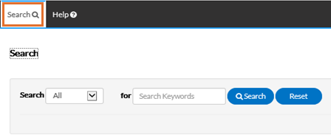
Select the type of record to search for from the Search dropdown.

All
1. Type relevant search keywords in the “for” field.
2. Click Search to display a list of results that meet the search criteria. Click Reset to clear the entered search criteria.

Search Permits
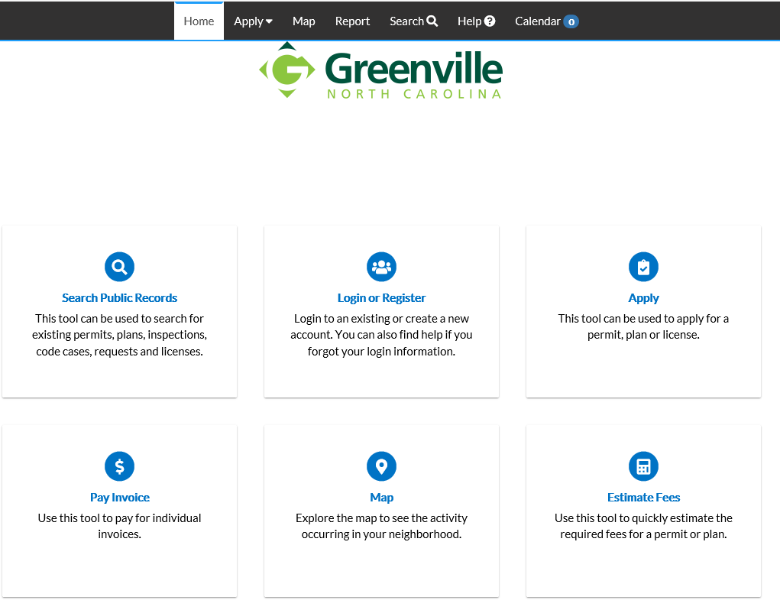
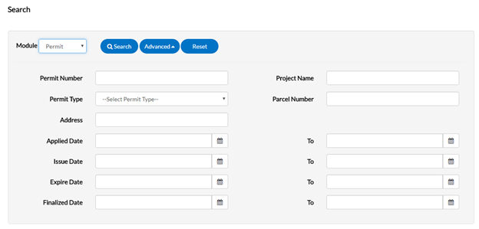
Users do not have to utilize all fields.

1. Type at least part of the permit number to search for in the Permit Number field.
2. Type at least part of the name of the project associated to the permit to search for in the Project Name field.
3. Select the type of permit to search for from the Permit Type dropdown.
4. Type at least part of the address associated to the permit to search for in the Address field.
5. Type a range of permit issue dates to search for permits within in the Issue Date and To fields, or click the calendar icons to select the dates.
6. Type a range of permit expiration dates to search for permits within in the Expire Date and To fields, or click the calendar icons to select the dates.
7. Type a range of permit finalization dates to search for permits within in the Finalized Date and To fields, or click the calendar icons to select the dates.
8. Click Search to display a list of results that meet the search criteria. Click Reset to clear the entered search criteria. Click Advanced to hide the search criteria.

Search Plans
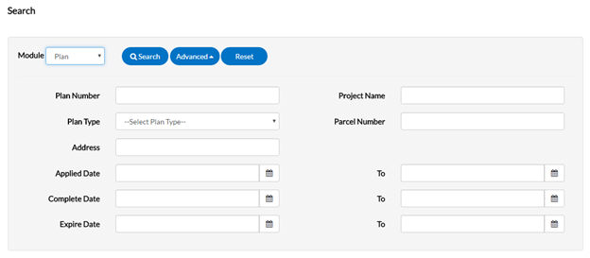
Users do not have to utilize all fields.

1. Type at least part of the plan number to search for in the Plan Number field.
2. Type at least part of the name of the project associated to the plan to search for in the Project Name field.
3. Select the type of plan to search for from the Plan Type dropdown.
4. Type at least part of the address associated to the plan to search for in the Address field.
5. Type a range of plan application dates to search for plans within in the Applied Date and To fields, or click the calendar icons to select the dates.
6. Click Search to display a list of results that meet the search criteria. Click Reset to clear the entered search criteria. Click Advanced to hide the search criteria.

Search Inspections
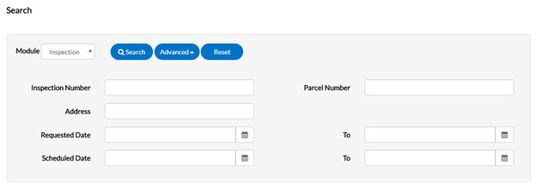
Users do not have to utilize all fields.
1. Type at least part of the inspection number to search for in the Inspection Number field.
2. Type at least part of the address associated to the inspection to search for in the Address field.
3. Type a range of inspection request dates to search for inspections within in the Requested Date and To fields, or click the calendar icons to select the dates.
4. Type a range of inspection schedule dates to search for inspections within in the Scheduled Date and To fields, or click the calendar icons to select the dates.
5. Click Search to display a list of results that meet the search criteria. Click Reset to clear the entered search criteria. Click Advanced to hide the search criteria.

Log In/To Register
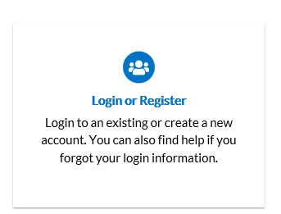

IMPORTANT NOTE: Before you register on the site, please contact Inspections to provide an email address for your company. This email will link your system account with your online account. If you do not do this prior to registering, your online account may not be linked to the correct system account which will cause you to not see open permits, schedule inspections, etc.
- Click on the Register button.
- Enter email address. Click Next.
- An email will be sent to the account. Log in to your email and open the email titled “Citizen Self Service New User Account Confirmation”.
- Open email, click the link and fill out the required information to complete registration.

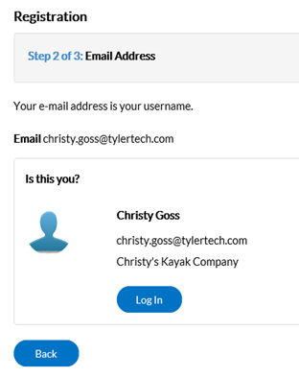

HOME
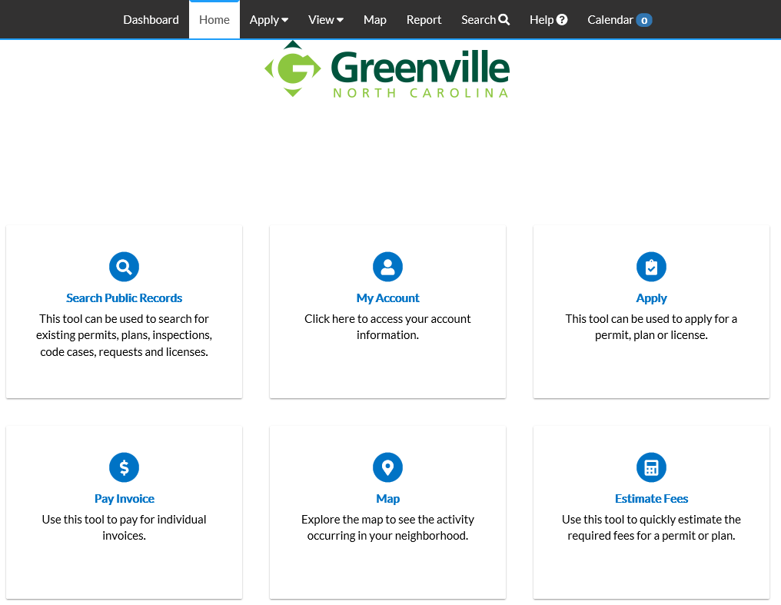

To access your account information select the “My Account” icon.
To access the Dashboard, click on the Dashboard option on the tool bar.

Dashboard
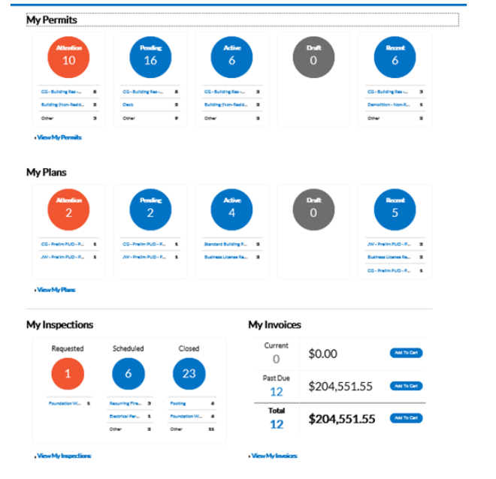

CSS allows users to see a visual representation of aggregated data on the dashboard. Users can see data for permits, plans, inspections, and invoices. Users can click the Draft circles to access saved drafts and also add unpaid invoices directly to the shopping cart. The dashboard displays data that is contextual to the logged in user.
1. Click Draft in the Permits or Plans section to view saved Permit or Plan application drafts.
2. Click the appropriate status circle in the Permits section to view a list of the corresponding Permits. Beneath each status circle is a breakdown of the Permit Types. Click View Full List to view all Permits.
3. Click the appropriate status circle in the Plans section to view a list of the corresponding Plans. Beneath each status circle is a breakdown of the Plan Types. Click View Full List to view all Plans.
4. Click the appropriate status circle in the Inspections section to view a list of the corresponding Inspections. Beneath each status circle is a breakdown of the Inspection Types. Click View Full List to view all Inspections.
5. Click Add to Cart next to Current, Past Due, or Total in the Invoices section to add the corresponding Invoices to the Shopping Cart. Click View Full List to view all Invoices.

Permits
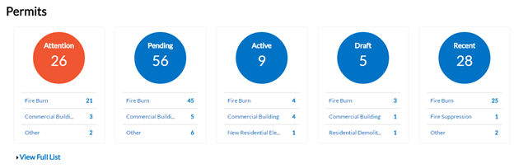
Field Name | Description
Attention | Clicking the Attention status circle on the Dashboard displays a list of all permit numbers applied for that have a status of Attention. The list shows the project name, address attached to the permit, type, status, and the reason that the permit needs the citizen’s attention.
Pending | Clicking the Pending status circle on the Dashboard displays a list of all permit numbers applied for that have a status of Pending. The list shows the project name, address attached to the permit, type, status, and reason.
Active | Clicking the Active status circle on the Dashboard displays a list of all permit numbers applied for that have a status of Active. The list shows the project name, address attached to the permit, type, status, and reason.
Draft | Clicking the Draft status circle on the Dashboard displays a list of all saved but not yet submitted permit and plan applications. These drafts can be incomplete and action may resume at any point in time. Users can also delete them from this window if they are now unnecessary.  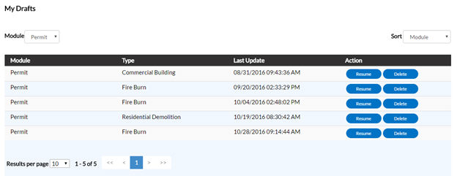
Recent | Clicking the Recent status circle on the Dashboard displays a list of all permit numbers applied for that have a status of Recent. The list shows the project name, address attached to the permit, type, status, and reason.
Field Name | Description
Display | This dropdown allows the citizen to organize and select a status to view.
Sort | This dropdown allows the citizen to sort by Permit Number, Project or Address.
Search | This allows the citizen to search by permit number, project name, or address by typing in the information and clicking the lookup icon.

Plans
IMPORTANT NOTE: While you may see plans that have been submitted to the City of Greenville, at this time the City is not accepting online applications for plans or payments for submitted plans.

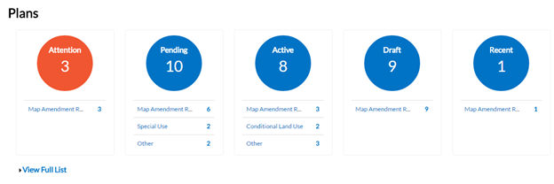

Field Name | Description
Attention | Clicking the Attention status circle on the Dashboard displays a list of all plan numbers applied for that have a status of Attention. This list shows the project name, address attached to the plan, type, status, and the reason that the plan needs the citizen’s attention.
Pending | Clicking the Pending status circle on the Dashboard displays a list of all plan numbers applied for that have a status of Pending. The list shows the project name, address attached to the plan, type, status, and reason.
Approved | Clicking the Approved status circle on the Dashboard displays a list of all plan numbers applied for that have a status of Approved. The list shows the project name, address attached to the plan, type, status, and reason.
Denied | Clicking the Denied status circle on the Dashboard displays a list of all plan numbers applied for that have a status of Denied. This list shows the project name, address attached to the plan, type, status, and reason.
Draft | Clicking the Draft status circle on the Dashboard displays a list of all saved but not submitted permit and plan applications. These drafts may be incomplete and action may resume at any point in time. Users can also delete them from this window if they are now unnecessary.
Recent | Clicking the Recent status circle on the Dashboard displays a list of all plan numbers applied for that have a status of Recent. The list shows the project name, address attached to the plan, type, status, and reason.

Inspections
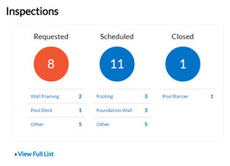
Field Name | Description
Requested | Clicking the Requested status circle on the Dashboard displays a list of all inspection case numbers that have a status of Requested. The list shows the address attached to the inspection, inspection type, and requested date.
Scheduled | Clicking the Scheduled status circle on the Dashboard displays a list of all inspection case numbers that have a status of Scheduled. The list shows the address attached to the inspection, inspection type, requested date, and scheduled date.
Closed | Clicking the Closed status circle on the Dashboard displays a list of all inspection case numbers that have a status of Closed. The list shows the address attached to the inspection, inspection type, requested date, and scheduled date.

Invoices
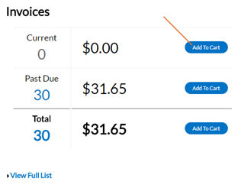
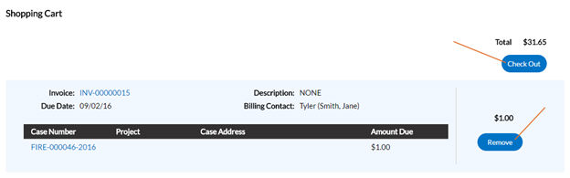

CSS users can access paid, voided, and unpaid invoices. Invoices are accessible from the Dashboard and the menu system and users can add them to the electronic shopping cart. CSS's integrated electronic shopping cart allows citizens to view, add, pay, or remove invoices, and displays single or multiple cases associated with each invoice.
Field Name | Description
Current | Clicking Add To Cart beside Current invoices allows citizens to access the Shopping Cart window where all current invoices display. The citizen can access an invoice by clicking on the invoice number or they can access the case by clicking on the case number. To remove an Invoice from the shopping cart, the citizen can click Remove. To check out, the citizen can click Check Out. This takes them to a payment window to complete the payment for the invoice(s).
Past Due | Clicking Add To Cart beside Past Due invoices allows the citizen to access the Shopping Cart window where all past due invoices display. The citizen can access the invoice by clicking on the invoice number or they can access the case by clicking on the case number. To remove an invoice from the shopping cart, the citizen can click Remove. To check out, the citizen can click Check Out. This takes them to a payment window to complete the payment for the invoice(s).
Total | Clicking Add To Cart beside Total invoices allows the citizen to access the Shopping Cart window where all invoices display. The citizen can access the invoice by clicking on the invoice number or they can access the case by clicking on the case number. To remove an invoice from the shopping cart, the citizen can click Remove. To check out, the citizen can click Check Out. This takes them to a payment window to complete the payment for the invoice(s).

Apply for Permits
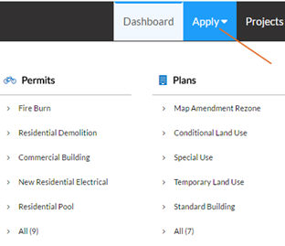

Field Name | Description
Apply | Select the appropriate permit/plan to apply for from the Apply dropdown. The Apply for Permit (or Apply for Plan) window opens and the type selected auto-populates. An asterisk (*) denotes required fields.  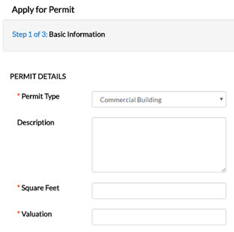
Description | The citizen needs to enter a description of the work that the permit/plan is for.
Square Feet (not required for all types) | The citizen needs to provide how many square feet the permit/plan occupies. This value must be greater than zero.
Valuation (not required for all types) | The citizen needs to provide the estimated cost of the task that the permit/plan relates to in this field. This value must be greater than zero.
Locations | Select the type of address from the dropdown. Click Add Location. An Add Location window displays. Manually enter or search for an address or parcel to add to the application. Click Submit when finished.  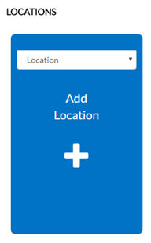  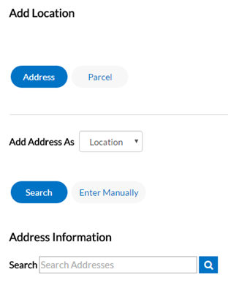
Contacts | The registrant’s contact information defaults to the first Contact card listed. To add contacts to the permit/plan application, click Add Contact. Select the contact type from the dropdown. In the search field, type a name, email, or company name and click the lookup icon to search the Global Contacts in EnerGov for an existing contact. If the person, email, or company is an existing contact, click Add to add the contact to the application. If the contact does not exist in Global Contacts, click Enter Manually and fill in the required fields. Click Submit.  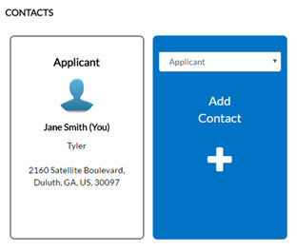  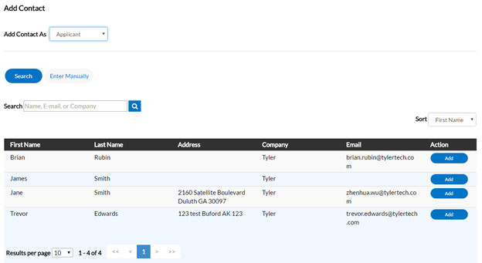
Attachments | Cards for required attachment types display automatically. Users must add required attachments before submitting the application. Click Add Attachment to open Windows Explorer. The citizen can select files or drag and drop them to add them as attachments to the application.  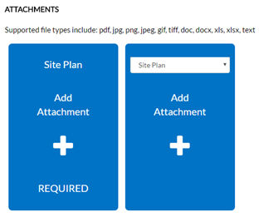
Save Draft | Click Save Draft if the information is incomplete and the citizen needs to finish it at a later date. The citizen can click the Draft status circle on the Dashboard to resume their application.
Next | Click Next to go to the Additional Information page. This page houses fields customized by the System Administrator.
Submit | Click Save to submit the application if no other fields are required.  If fields are blank and the user clicks Save Draft, Next, or Submit, an alert notifies the citizen that information is missing.

Request Inspections on Issued Permits

Once users have searched for permit and pulled update the details screen, users may schedule inspections from CSS.

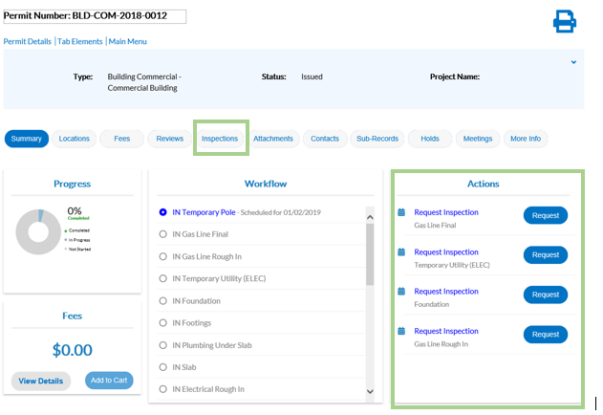
1. Choose the Inspections tab. A list of Remaining Inspections displays at the bottom.
2. Click Request. The Request Inspections window opens.

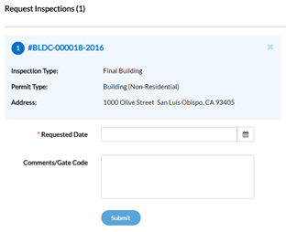

3. Select a requested date for the inspection by clicking the calendar icon beside the Requested Date field.
4. Fill in comments about the requested inspection in the Comments/Gate Code field if applicable.
5. Click Submit. The inspection information and a green check mark display if the request is successful.
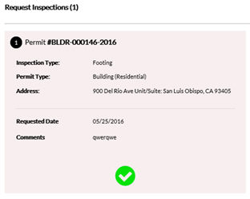
6. Navigate back to the Permit Details window. The inspection now displays under Existing Inspections in the full list of inspections.

Pay Fees
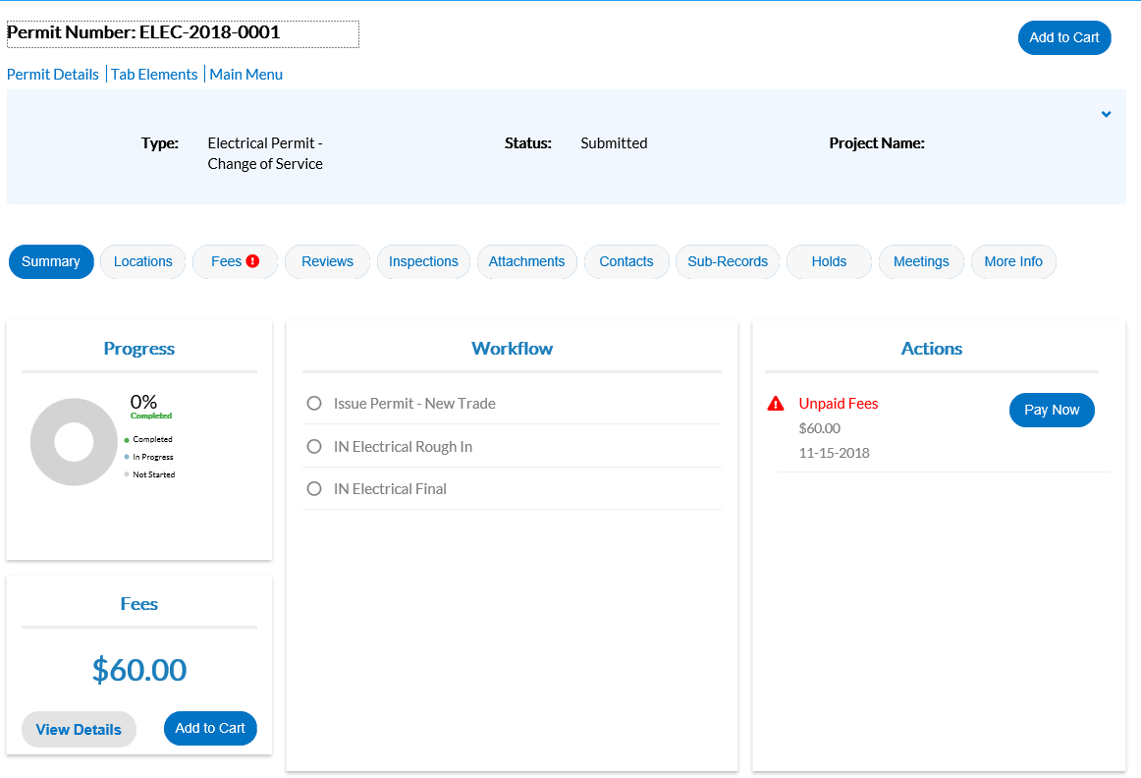

To pay fees on a plan/permit, the citizen needs the case manager to invoice the fees in EnerGov.
1. Navigate into a plan/permit.
2. Choose the Fees tab. The citizen can see a list of Remaining Fees and Paid Fees with invoice numbers next to the fee names or click on buttons under the Fees box, View Details or Add to Cart.

Invoices
CSS users can access paid, voided, and unpaid invoices. Invoices are accessible from the dashboard and the menu system and users can add them to the electronic shopping cart.

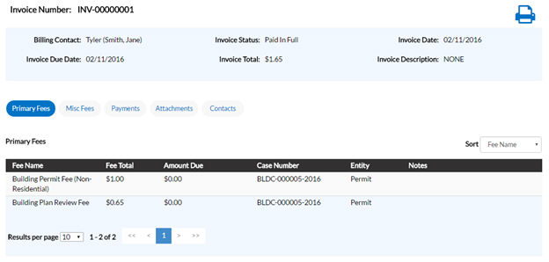
Follow the steps below to view invoice information:
1. Click the printer icon to print or save the invoice as PDFs.
2. Choose the Primary Fees tab to view the Fee Name, Fee Total, Amount Due, Reference Entity, Entity, and Notes for all fees associated with the invoice. Select the column to sort the fees by from the Sort dropdown.
3. Choose the Misc Fees tab to view the Fee Name, Fee Total, Paid Amount, and Amount Due for all miscellaneous fees associated with the invoice. Select the column to sort the fees by from the Sort dropdown.
4. Choose the Payments tab to view the Receipt Number, Status, Transaction Type, Payment Type, Payment Amount, and Payment Date for all payments associated with the invoice. Select the column to sort the payments by from the Sort dropdown.
5. Choose the Attachments tab to view the File Name and Added Date for all files attached to the invoice. Select the column to sort the attachments by from the Sortdropdown.
6. Choose the Contacts tab to view the Company, First Name, Last Name, Title, and Email for all contacts associated with the invoice. Select the column to sort the contacts by from the Sort dropdown.
7. Click Add to Cart to add the invoice to the shopping cart.

View
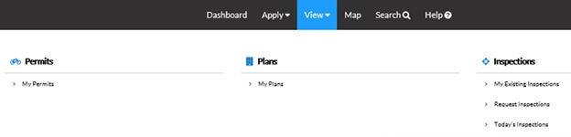
Use the View tab at the top of the Dashboard window to access My Permits, My Plans, and Inspections.

My Permits
CSS allows users to view the details of a permit.
Follow the steps below to view permits:
Not all permit data is available to all users.
1. Type a specific permit number, project, or address to search for in the search field, and click the lookup icon to locate permits that meet the search criteria.
2. Select the statuses of the permits to display in the list from the Display dropdown.
3. Select the feature to sort the permits in the list by from the Sort dropdown.
4. Click a permit number to open the associated permit record.
5. Select the number of permits to display on each page from the Results per page dropdown.
6. Use the page navigation buttons to move between pages of permits.

My Plans
CSS allows users to view the details of a plan.
Follow the steps below to view plans:
Not all plan data is available to all users.
1. Type a specific plan number, project, or address to search for in the search field, and click the lookup icon to locate plans that meet the search criteria.
2. Select the statuses of the plans to display in the list from the Display dropdown.
3. Select the feature to sort the plans in the list by from the Sort dropdown.
4. Click a plan number to open the associated plan record.
5. Select the number of plans to display on each page from the Results per page dropdown.
6. Use the page navigation buttons to move between pages of plans.

Inspections

My Existing Inspections
Use this window to view, sort, and access all available inspections.
Follow the steps below to view inspections:
1. Type a specific case number, address, or inspection type to search for in the search field, and click the lookup icon to locate inspections that meet the search criteria.
2. Select the statuses of the inspections to display in the list from the Display dropdown.
3. Select the feature to sort the inspections in the list by from the Sort dropdown.
4. Click a case number to open the associated record if desired.
5. Select the number of inspections to display on each page from the Results per page dropdown.
6. Use the page navigation buttons to move between pages of inspections.

Request Inspections
CSS provides a great way for users to request inspections. Users must log in to CSS to request inspections, and they must be contacts associated with the cases. Users can request multiple related/unrelated inspections simultaneously. Inspection requests interact with the inspection-related data on the dashboard.
Follow the steps below to view inspections:
1. Type a specific permit number, address, or inspection type to search for in the search field, and click the lookup icon to locate inspections that meet the search criteria.
2. Select the feature to sort the inspections in the list by from the Sort dropdown.
3. Click a permit number to open the associated permit record. Or, mark the checkboxes next to permits to request inspections for, and click Request Inspection to open the Request Inspections window.
4. Select the number of inspections to display on each page from the Results per page dropdown.
5. Use the page navigation buttons to move between pages of inspections.

Today's Inspections
Use this window to view, sort, and access all inspections scheduled for a specific day.
Follow the steps below to view inspections:
1. Type a specific case number, inspection type, or address to search for in the search field, and click the lookup icon to locate inspections that meet the search criteria.
2. Type the date to view due inspections for in the Date field, or click the calendar icon to select the date.
3. Mark the Exclude Completed checkbox to exclude completed inspections from the list of results.
4. Select the feature to sort the inspections in the list by from the Sort dropdown.
5. Select the number of inspections to display on each page from the Results per page dropdown.
6. Use the page navigation buttons to move between pages of inspections.

ADA Compliance
CSS and CSS Administration are Americans with Disabilities Act (ADA)-compliant at the WCAG 2.0 AA level. Numerous features make the site accessible to individuals with various impairments. For the Speak to Read feature to work in CSS, users need to install ChromeVox. ChromeVox is an extension for Chrome on Windows and Mac OS X that operates as an alternative screen-reader for Web content. ChromeVox speaks the content of the page, plays audio indicators for page load progress and objects on the page, and provides a way to navigate all web content from the keyboard.
Install this feature here: http://www.chromevox.com/installing.html.

