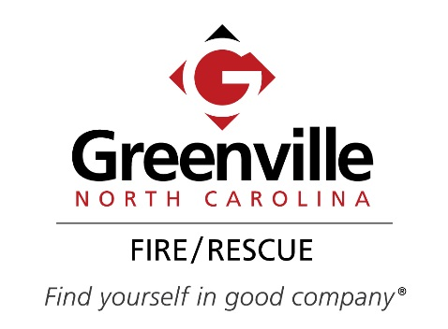
Application for State Required Inspection for License
Application Fee: |  |  | $50.00 – City Limits/per building  $80.00 – Extra Territorial Jurisdiction (ETJ)/per building
 | Select Type
 | Foster Care |  |  |  |  | Day Treatment Center
 | Daycare |  |  |  |  | Mental Health Facility
 | Group Home |  |  |  |  | Other _______________
 |  |  |  |  |  | Total Amount |  |  |  | $
Applicant/Company: |  |  |  |  |  |  |  | Facility ID #
Address:
Contact Name: |  |  |  |  |  |  | Telephone:
Contact Email:
Comments:
Common items checked during a state required inspection for license
- Fire Extinguishers – “ABC” Fire extinguishers are mounted and in working order.
- Extension Cords – Extension cords are not substituted for permanent wiring.
- Exits – All exits/doors are unobstructed and pathways are clear.
- Smoke Alarms – Smoke alarms are properly installed and in working order.
- Evacuation Plan – Evacuation plan is posted in a prominent location.
- Emergency Numbers – There is a working telephone with emergency contact numbers posted.
- Carbon Monoxide Detectors – Carbon Monoxide detector installed in homes that use fuel oil products, coal, wood or gas to heat, cook, etc.
Mail Application and payment to: Greenville Fire/Rescue, PO Box 7207, Greenville, NC 27835
OR Submit in person to: Greenville Fire/Rescue, 500 S. Greene St, Greenville, NC 27834
OR E-mail to FireRescueRequests@greenvillenc.gov for Credit Card payment by phone at (252) 329-4391
Make checks payable to: City of Greenville
Signature: |  |  |  |  |  |  |  |  | Date:

Fire/Rescue Use Only
Date Received: |  | Receipt/Permit #:

Updated 12/18/19

