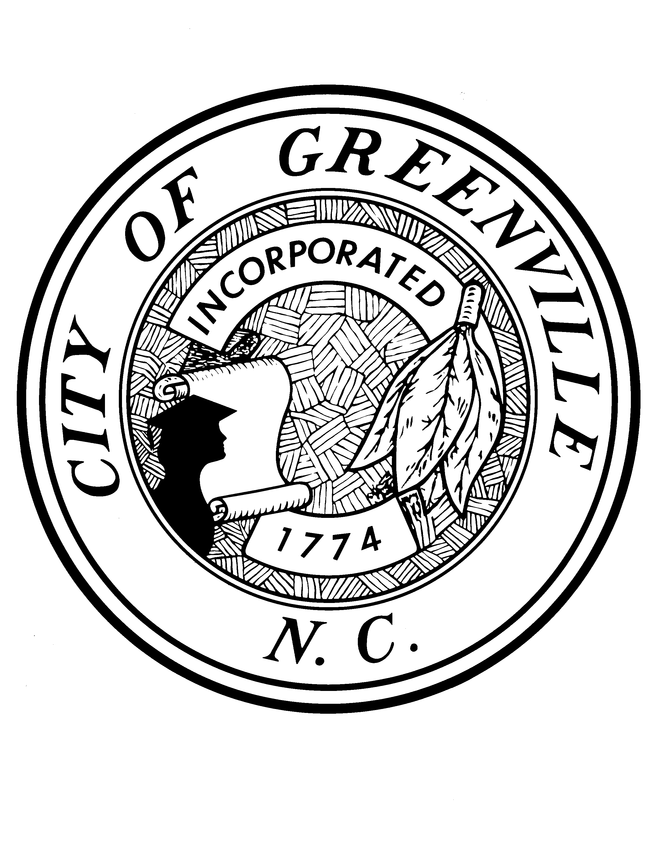

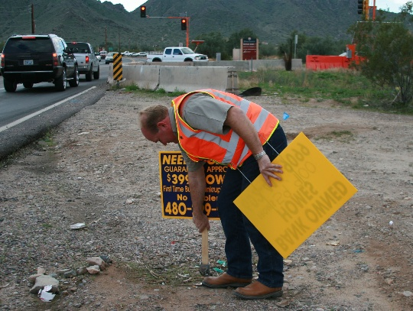
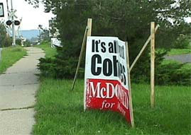

The Purpose
This pamphlet is a user friendly tool to answer many of the questions asked staff about temporary signs in the City of Greenville. Many of the questions answered within this pamphlet include the following:

- What are temporary signs?
- What are exempt signs?
- What are the square footage regulations for real estate signs?
- What signs do not require a building permit or zoning approval?
- Are temporary signs entitled to a legally nonconforming status?
- What are the prohibited signs and the exceptions?
- What special event signs are allowed and time limits?
- What are the square footage coverage limits for windows and doors?
- Are flags allowed?

Let’s all team up and work together in partnership to keep our community safe and clean!
Contact Information
Post Office Box 7207
Greenville, NC 27835 – 7207

City Municipal Building
201 West 5th Street, Second Floor
Greenville, NC 27834

Phone: 252-329-4110
Fax: 329-4231

www.greenvillenc.gov

Code Enforcement Division
Property Maintenance Standards

City of Greenville Police Department

Code Enforcement Division’s
Guide to Understanding

Temporary Signs

Definitions
[Sec 9-4-222]

Temporary Sign: Any portable advertising sign which attracts the public attention to an event or specific products sold. Such signs include the following:
- Signs made of paper, cloth, polyethylene film.
- Signs not permanently affixed to the ground or building surface as approved by the building inspector.
- Trailer signs
- Balloons exception 9-4-227
- Portable signs
- Banners, flags and other similar materials
No Permits required (Exempt Signs):
[Sec 9-4-227]

- Residential signs- noncommercial
Purpose, e.g. address or identification 3 sq. ft. limit.
- Memorial plaques
- On-premises signs with a governmental purpose
- On premises governmental or nonprofit balloons, flags, Insignia
- Architectural features of a bldg.
- Directional signs on property, e.g. signs for restroom, exits, parking
3 sq. ft. limit
- Signs permanently attached to a licensed motor vehicle.

The City of Greenville Guide to Understanding Temporary Signs

Exempt signs cont’d

- Certain temporary signs
- Election signs
- Holiday signs remove 10 days after event
- Construction identification signs
- Interior bldg signs with no more than 25% coverage of windows or doors. Painted signs are not temporary.
- Temporary non illuminated real estate signs provided:
- 12 sq. ft. area limit residential zones
- 50 sq. ft. area limit commercial
- Other temporary (commercial) signs
- Not more than one sign per lot
- 6 sq. ft. area limit
- Only applicable to commercial zones
Special provisions for certain signs

[Sec 9-4-233]

k. Temporary on-premises special event Spotlights
and Roof Mounted Inflated Balloons:
- Restrictions for spotlights
  - a. No more than one spotlight per lot.
  - Two (2) consecutive day limit
  - Display limited to 20 days in one year

- Roof mounted Inflatable balloons
  - Restrictions same as spotlights

Signs Not Allowed
(Prohibited Signs)

[Sec 9-4-237]

- Kites
- Balloons except as described.
- Spotlights except as described.
- Flags exceeding 100sq ft commercial use
- Temporary signs except as described
- Attached signs to radio/TV towers or poles
- Suspended signs between two structures or poles
- Roof signs except as described.
- Revolving signs
- Flashing signs except time and temperature
- Strings, ribbons, tinsels, small flags
- Pinwheels, windmills, or other devices
Nonconforming Signs. [Section 9-4-225]

(f.) All temporary signs existing on the effective date (November 13, 1986) of this article which do not conform to the requirements…shall be removed...

