Current Needs: 1) Execution of Memorandum of Agreement by NCDOT, NCSHPO, and FTA; 2) FTA approval of Environmental Assessment and Finding of No Significant Impact (FONSI)
Status: FTA reviewing Environmental Assessment. Parcel appraisals completed. No public controversy or community opposition to preferred site. Staff has scheduled informational meeting for property owners for December 12, 2009.
Public Communication: Dedicated project web site maintained by City staff---www.greatnc.com. Public meetings and periodic written communication with property owners.
Intermodal Center Site: Uptown Greenville, bounded by Evans St., East 8th St., Cotanche St., and East 9th St. Twenty-one parcels, three of which are either State owned or owned by the City. Eighteen parcels controlled by thirteen property owners.
Project Issues: Historic property for architecture---Jones Lee House; two off site parcels that would likely qualify for National Register for Historic Places. Impact mitigation efforts outlined in Memorandum of Agreement.
Federal Earmarks:
Expansion Buses and Intermodal Center FFY 2007 E2007 BUSP-366 $715,081
Expansion Buses and Intermodal Center FFY 2008 E2008 BUSP-365 $774,671
Expansion Buses and Intermodal Center FFY 2009 E2009 BUSP-533 $804,466
Available for Land Acquisition and Design Total $2,294,218 plus Local and State Match – 20%
Project Cost Estimate based on (STIP)
Federal $4,800,000
Local $600,000
State $600,000
Total $6,000,000

Current Construction Estimate (Moser Mayer Phoenix 2009)
Land/Acquisition/Demolition & Environmental $2,928,000
Design/Surveys $710,879
Construction/FFE/Contingency $7,279,902
Total $10,936,781
Community Involvement: Public comment at City Council meetings, public input meetings, Steering Committee meetings, dedicated project website, information on Greenville Government Access Channel and notices published in local daily newspaper.
Aerial View of Intermodal Center Site
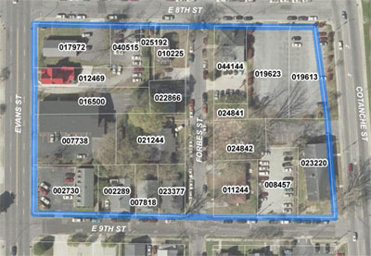
Administrative Project Manager: Thomas M. Moton, Jr., Assistant City Manager
Email: tmoton@greenvillenc.gov
Office: 252.29-4432
GREAT Transit Manager: Nancy Harrington
Email: nharrington@greenvillenc.gov
Office: 252.329-4047
Doc. 849492v2

